Лабораторная работа №2

Ввод-вывод при помощи libc

Выполнили студенты ПМ-31 Шлыков И.

Янышев Б.

Задание №1

#include<iostream>

short* initial16(short a )

{

short* Arr = new short[5];

for (int i = 0; i < 5; i++)

{

Arr[i] = a;

printf("0x%04x ",Arr[i]);

}

printf("\n");

return Arr;

}

int* initial32(int a)

{

int* Arr = new int[5];

for (int i = 0; i < 5; i++)

{

Arr[i] = a;

printf("0x%08x ", Arr[i]);

}

printf("\n");

return Arr;

}

char* initial8(char a)

{

char* Arr = new char[5];

for (int i = 0; i < 5; i++)

{

Arr[i] = a;

printf("0x%02x ", Arr[i]);

}

printf("\n");

return Arr;

}

long long* initial64(long long a)

{

long long* Arr = new long long[5];

for (int i = 0; i < 5; i++)

{

Arr[i] = a;

printf("0x%016x ", Arr[i]);

}

printf("\n");

return Arr;

}

float* initial32f(float a)

{

float* Arr = new float[5];

for (int i = 0; i < 5; i++)

{

Arr[i] = a;

printf("%.20f \n", Arr[i]);

}

printf("\n");

return Arr;

}

double* initial64d(double a)

{

double* Arr = new double[5];

for (int i = 0; i < 5; i++)

{

Arr[i] = a;

printf("%.51f \n", Arr[i]);

}

printf("\n");

return Arr;

}

int main()

{

float x = exp(1);

double y = exp(1);

char* a = initial8(258);

short* c = initial16(16755);

int* b = initial32(1245);

long long* d = initial64(425254345315);

float* e = initial32f(x);

double* f = initial64d(y);

delete a;

delete b;

delete c;

delete d;

delete e;

delete f;

return 0;

}

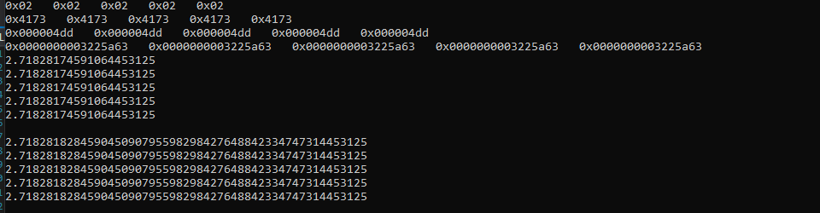

Задание №2

#define _CRT_SECURE_NO_WARNINGS

#include<iostream>

#include"string.h"

short* initial16(short a )

{

short *Arr = (short*)malloc(5 * sizeof(short));

for (int i = 0; i < 5; i++)

{

Arr[i] = a;

printf("0x%04x ",Arr[i]);

}

printf("\n");

return Arr;

}

int* initial32(int a)

{

int* Arr = (int*)malloc(5*sizeof(int));

for (int i = 0; i < 5; i++)

{

Arr[i] = a;

printf("0x%08x ", Arr[i]);

}

printf("\n");

return Arr;

}

char* initial8(char a)

{

char* Arr = (char*)malloc(5 * sizeof(char));

for (int i = 0; i < 5; i++)

{

Arr[i] = a;

printf("0x%02x ", Arr[i]);

}

printf("\n");

return Arr;

}

long long* initial64(long long a)

{

long long* Arr = (long long*)malloc(5 * sizeof(long long));

for (int i = 0; i < 5; i++)

{

Arr[i] = a;

printf("0x%016x ", Arr[i]);

}

printf("\n");

return Arr;

}

float* initial32f(float a)

{

float* Arr = (float*)malloc(5 * sizeof(float));

for (int i = 0; i < 5; i++)

{

Arr[i] = a;

printf("%.20f \n", Arr[i]);

}

printf("\n");

return Arr;

}

double* initial64d(double a)

{

double* Arr = (double*)malloc(5 * sizeof(double));

for (int i = 0; i < 5; i++)

{

Arr[i] = a;

printf("%.51lf \n", Arr[i]);

}

printf("\n");

return Arr;

}

int main()

{

float x = exp(1);

double y = exp(1);

char* a = initial8(258);

short* b = initial16(16755);

int* c = initial32(1245);

long long* d = initial64(425254345315);

float* e = initial32f(x);

double* f = initial64d(y);

scanf("%hhd", &a[2]);

for(int i=0;i<5;i++)

printf("0x%02x ", a[i]);

printf("\n");

scanf("%hd", &b[2]);

for (int i = 0; i < 5; i++)

printf("0x%04x ", b[i]);

printf("\n");

scanf("%ld", &c[2]);

for (int i = 0; i < 5; i++)

printf("0x%08x ", c[i]);

printf("\n");

scanf("%lld", &d[2]);

for (int i = 0; i < 5; i++)

printf("0x%016x ", d[i]);

printf("\n");

scanf("%f", &e[2]);

for (int i = 0; i < 5; i++)

printf("%.20f \n", e[i]);

printf("\n");

scanf("%lf", &f[2]);

for (int i = 0; i < 5; i++)

printf("%.51lf \n", f[i]);

printf("\n");

free(a);

free(b);

free(c);

free(d);

free(e);

free(f);

return 0;

}

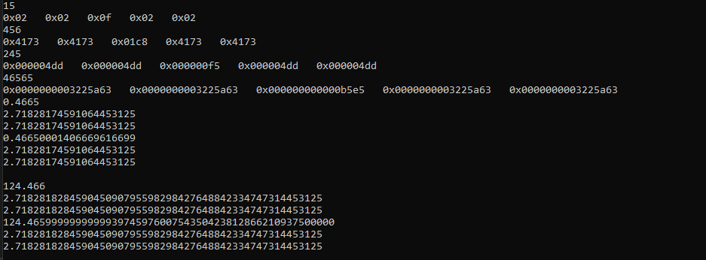

Задание №3

scanf("%hd%hd%hd%hd%hd",&b[0],&b[1],&b[2],&b[3],&b[4]);

for(int i=0;i<5;i++)

printf("0x%04x ", b[i]);

printf("\n");

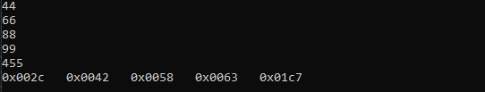

Задание №4

[#define](https://vk.com/im?sel=445761352&st=%23define) _CRT_SECURE_NO_WARNINGS  
[#include](https://vk.com/im?sel=445761352&st=%23include) <iostream>  
[#include](https://vk.com/im?sel=445761352&st=%23include) <stdio.h>  
[#include](https://vk.com/im?sel=445761352&st=%23include) <string>  
  
int main()  
{  
std::string * s1, * s2, * s3;  
std::string buff;  
std::string kost(" ");  
printf("Enter s1\n");  
getline(std::cin,buff);  
buff.erase(buff.find(kost,0));  
s1 = new std::string[sizeof(buff) + 1];  
*s1 = buff;  
printf("Enter s2\n");  
getline(std::cin, buff);  
s2 = new std::string[sizeof(buff) + 1];  
*s2 = buff;  
printf("Enter s3\n");  
getline(std::cin, buff);  
s3 = new std::string[sizeof(buff) + 1];  
*s3 = buff;  
std::cout « "***" « *s1 « "***\n";  
std::cout « "***" « *s2 « "***\n";  
std::cout « "***" « *s3 « "***\n";  
  
  
delete s1;  
delete s2;  
delete s3;

}

#define _CRT_SECURE_NO_WARNINGS

#include <stdio.h>

#include <string>

#include<iostream>

int main()

{

char s1[255];

char s2[255];

printf("Enter s1\n");

scanf("%s",s1);

printf("Enter s2\n");

std::cin.clear();

while(std::cin.get()!='\n');

scanf("%[^\r\n]", s2);

printf("***%s***\n",s1);

printf("***%s***\n", s2);

}

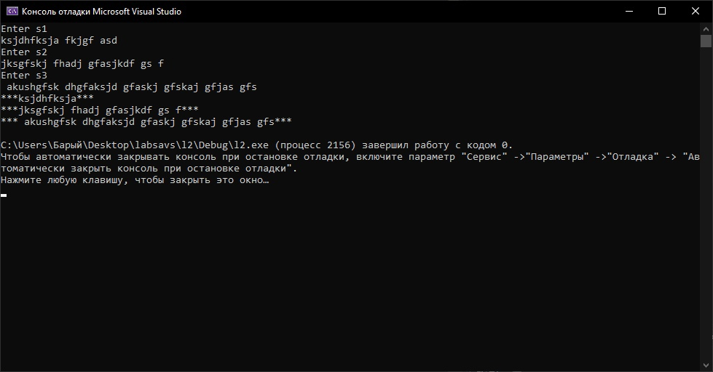

Задание №5

for (int i = 0; i < 5; i++)

printf(" 0x%02x ", a[i]);

printf("\n");

for (int i = 0; i < 5; i++)

printf(" 0x%04x ",b[i]);

printf("\n");

for (int i = 0; i < 5; i++)

printf(" 0x%08x ", c[i]);

printf("\n");

for (int i = 0; i < 5; i++)

printf(" 0x%016x ", d[i]);

printf("\n");

for (int i = 0; i < 5; i++)

printf(" %.11f ", e[i]);

printf("\n");

for (int i = 0; i < 5; i++)

printf(" %.16lf ", f[i]);

printf("\n");

